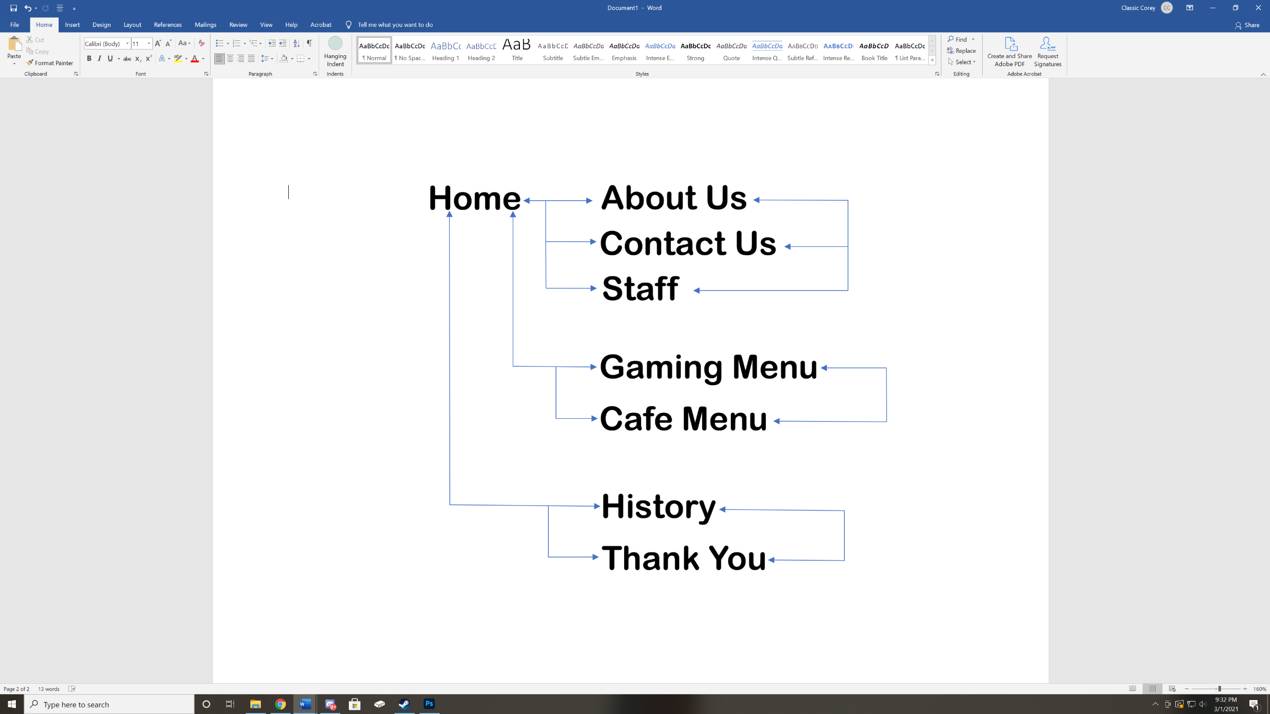

Graphics

Universal Style Sheet (CSS)